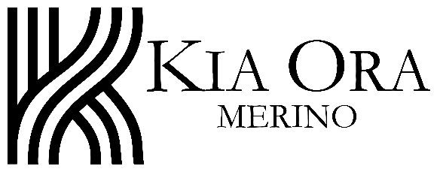 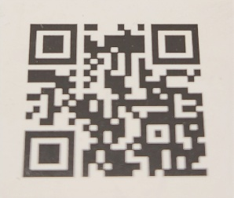

Kia Ora Australian Merino wool Felt hats.

The hat is made from 100- 110 grams of 15 - 17-micron Merino wool. It is soft and light, so feels like wearing a cloud. The hats have a deep crown so know it will stay in place.

Botanically dyed hats are colored by Eucalyptus leaves making orange and brown/green colors. The yellow is wattle however when unavailable purple Buddleia flowers are used. The botanically dyed hats are made from our ultra fine wool, Kia Ora Merino, Winslow, Australia. This wool is hand felted with soap, warm water and lots of rubbing / rolling. The commercially dyed hats are also hand felted using a wool top from Nundle Woollen Mill (NSW) who source from a Tasmanian Merino wool farm.

Hat Band: The attached kangaroo leather hat band has a slide knot. When at the correct length it can pull tight and will fix in place. The knot is usually worn on the left-hand side of the crown. A woven or ribbon band can also be used.

Hat care:

1. The hat dyes are water fast if the hat becomes wet just shake off extra moisture.
2. If the hat becomes fluffy or pills a quick shave with a razor will fix it. This may happen after a lot of wear.
3. Store the Fedora style hat upside down, on its crown. Bowler hats on their brim.
4. If the hat has a crease a warm spoon rubbed behind the crease will ease it. The hat is initially molded with steam so if you want to reverse/ invert the hat use steam and give it a rub to keep in place.
5. The hat can be squished etc. and popped back up.
6. Spot stains with warm water and mild soap if needed. Never wash in a washing machine or dry in a spin dryer as the hat will felt further and may become misshapen.

Fedora Hats – hold by the brim tip and place on your head, then push down on the top of the crown.