**Meet the 11-year-old helping keep a thousand-year-old tradition alive**

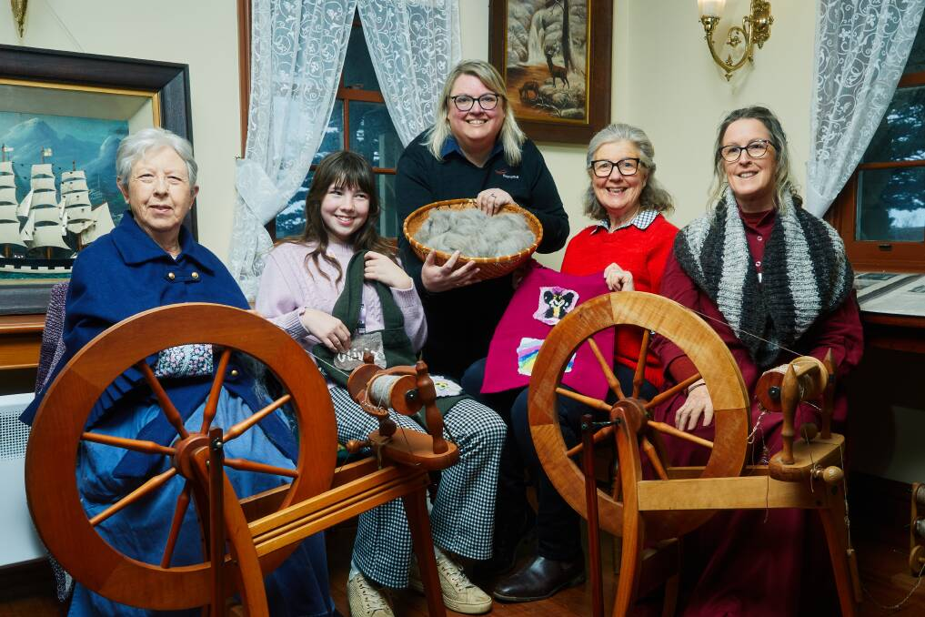 [William Stanley](https://www.standard.net.au/profile/1672/william-stanley/)**Updated**July 11 2025

Pauline Pearson, Olivia Finnigan, Kate Wake, Susan Finnigan, Angela Rea. Picture by Warrnambool City Council

From ugg boots to blankets, wool has been used for thousands of years to keep us warm during the chilly winter nights. Making things out of wool isn't for everyone, but for 11-year-old Olivia Finnigan, it's in her blood.

Olivia's grandmother Susan Finnigan passed down the wool genes. A bond they now share and continue to love.

"You get little pieces of wool and go horizontally and vertically in tiny little pieces until you make an image," Olivia said about her pastime of making felted pictures. It doesn't take long once you get used to the process. It’s a lot of fun. A picture takes about 30 minutes, but something like a bookmark would only take three minutes.It doesn't take that long once you get used to the process."

After a successful inaugural wool weekend in 2024, Warrnambool's [Flagstaff Hill Maritime Museum is again promoting wool.](https://www.standard.net.au/story/8715869/warrnambool-pushes-600k-plan-to-revitalise-flagstaff-hill/)

[Flagstaff Hill](https://www.standard.net.au/story/8974014/flagstaff-hill-stars-in-new-series-bolstering-warrnambool-tourism/) Maritime Museum coordinator, curator and experience Kate Wake is excited to open the doors and take attendees on a journey that celebrates everything wool.

"We'll be having demonstrations of blade shearing, which was the traditional way of shearing a sheep before the mechanical shearing techniques came in," Ms Wake said. Attendees will have the opportunity to become wool experts for the weekend. There will be stalls where Olivia will demonstrate how to make a felted picture or pen.

"It's a great opportunity for locals to sign up and bring their friends and relatives visiting Warrnambool to experience Flagstaff Hill," Ms Wake said.

Wool weekend activities run from 11am-3pm on Saturday, July 12 and Sunday, July 13.