**Warrnambool Weekly 11 July, 2025**

**Wool weekend at Flagstaff Hill**

**FAMILIES looking for some school holiday fun this weekend should head to Flagstaff Hill for ‘wool weekend.’**

**By Staff Writer**

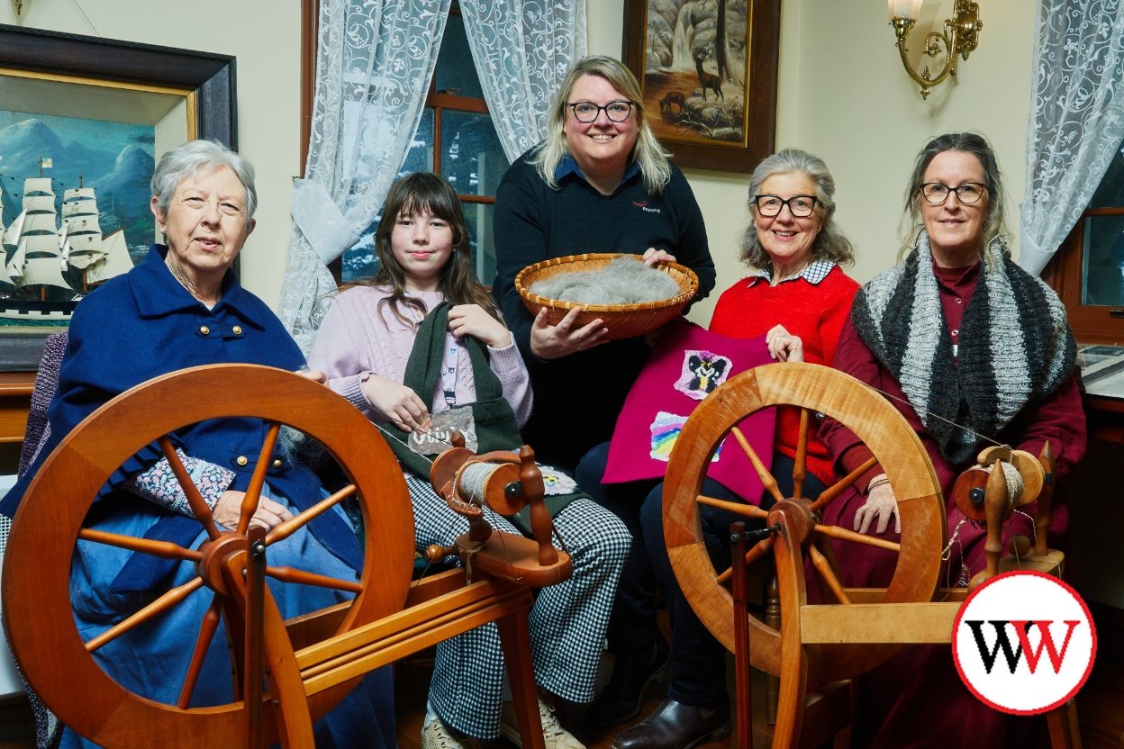

***Flagstaff Hill volunteer weaver Pauline Pearson (left) with Olivia Finnigan, Flagstaff Hill Maritime Museum coordinator curator and experiences Kate Wake, Susan Finnigan and Flagstaff Hill volunteer weaver Angela Rea. Picture courtesy Warrnambool City Council.***

Wool Weekend is a two-day event which will run from 11am until 3pm on both Saturday and Sunday.

The event was first held last year and forms part of Flagstaff Hill’s winter school holiday program.

Visitors will have the opportunity to discover the rich history of wool, from its origins to its modern-day uses.

See live demonstrations of traditional wool and fibre trades and crafts, including blade shearing, fleece preparation, yarn spinning, knitting, felting and dyeing.

Enjoy historical displays, meet the sheep and take part in interactive storytelling, hands-on activities and fun craft workshops.

Eleven year-old Olivia Finnigan will be the youngest exhibitor over the weekend – she is carrying on the tradition of making things out of wool, thanks to skills passed down by her grandmother.

Olivia and her grandmother Susan Finnigan were also at the inaugural Wool Weekend event last year, with their felting demonstration so popular it has expanded into a hands-on workshop.

Participants can either make a felted pencil cover or felted picture, with Olivia explaining the process of making a picture.

***“You get little pieces of wool and go horizontally and vertically in tiny little pieces until you make an image,” she said.***

“Then you wet it, cover it with mesh, wet that, rub it and that felts it. Then you do the same on the other side and once nothing is moving around you put it in hot water and then cold twice; it’s a lot of fun.”

Entry is free for locals, with general admission prices for those living outside the Warrnambool City Council municipality