Compassionate buy
Thursday May 12, 2022 THE STANDARD p.19
By Annabelle Cleeland
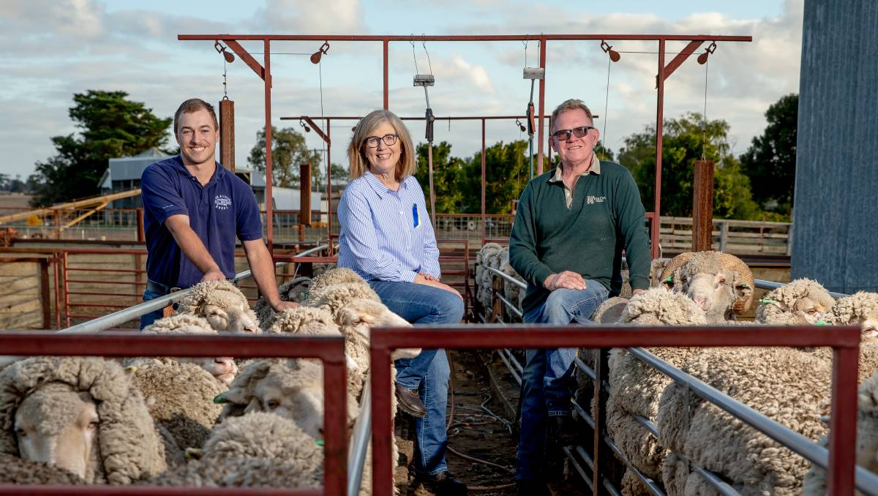
Fox and Lillie's Kyle Smitten with Brendan and Susan Finnigan, Kia Ora Merino, Winslow, who donated a bale of wool to raise funds for Ukraine's humanitarian crisis.Photo by Chris Doheny

Wool buyers generously dug deep to purchase a bale of wool for 8000 cents a kilogram greasy in Melbourne, with all proceeds going to the Ukraine humanitarian crisis.
The bale was bought by Global Merino, purchased through Fox & Lillie Australia and resulted in more than $12,000 contributed to the Ukraine Crisis Appeal, which provides urgent support to families such as shelter, food and healthcare.

Brendan and Susan Finnigan, Kia Ora Merino, Winslow, donated the 162 kilogram bale of Responsible Wool Standard certified wool, which measured 15.9 micron and had a comfort factor of 99.7.
"The crisis in Ukraine is abhorrent so it is wonderful to see Global Merino show their strength of compassion and buy the wool," Ms Finnigan said.
"It is a wonderful reflection of people in wool from two continents committing to a humanitarian cause."
The Finnigan's also donated a scarf, knitted by Wolfgang Scout co-founder Carla Voigt, which took 15 hours to make, from wool grown at Kia Ora and incorporated the Ukraine national colours.
Global Merino will incorporate the wool into a parcel of wool to create next to skin knitted fabric used in outdoor active wear garments.
Fox & Lillie national wool brokerage manager Eamon Timms said both companies wanted to support the humanitarian crisis.

"Global Merino wanted to do something practical in this troubling situation," Mr Timms said.
"While it is a generous amount, in the scheme of things so much more is needed.
"We hope that it will make some material difference to those people who need help with housing, food and medicine."
Mr Timms said the war in Ukraine was creating concerns for the Australian wool market and impacting the buying appetite of European users.
"Another factor causing consternation is the massive rise in the price of energy," he said.
"Some clients who had locked in gas contracts have been unable to get new contracts and have had to start paying the spot price - this is 500 to 600 per cent higher than what they had been paying and the impact of this is pushing up the price of processing wool significantly."

