NOVEMBER 13 2020 - 11:00AM

Winslow's Kia Ora Merino named Farm Biosecurity Producer of the Year in Australian awards

Kimberley Price

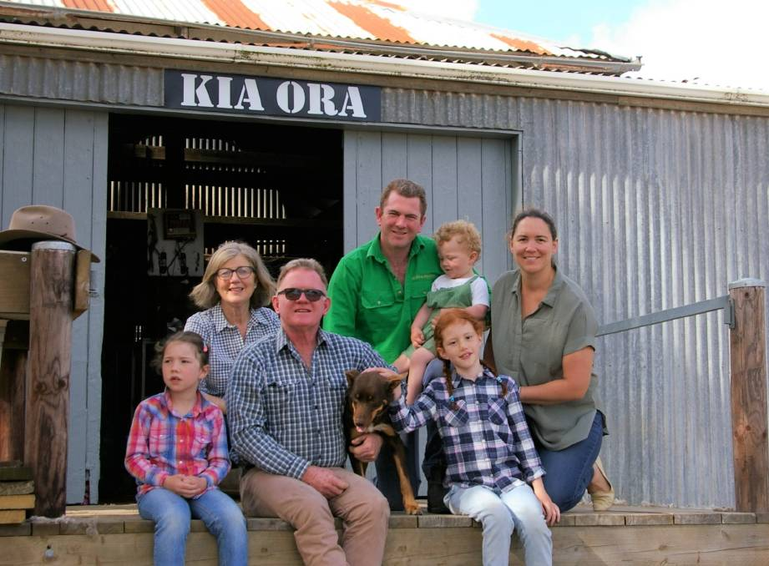
WINNERS: The Finnigan family, Olivia, Susan, Brendan, James holding his son Jim, Madison and Nicole at their wool shed.
Kia Ora Merino has been named Farm Biosecurity Producer of the Year in the Australian Biosecurity Awards.
Brendan, Susan, James and Nicole Finnigan are dedicated merino wool producers and have become leaders in on-farm biosecurity, sustainable land management and animal welfare practices.
Susan Finnigan said Australia's "clean and green" reputation had pushed the family to focus on their consumers and their end product. "We decided to embrace biosecurity and try to do the very best we could in the field, that's probably why we stand out a little bit," she said.
"In our ESP Wool production, we looked at what we do and decided we should look at what our customers want. We focused on the things they need; sustainability was one of them and includes being environmentally focused and profitable.
"Sustainability is all about the environment and that's all about farmers."
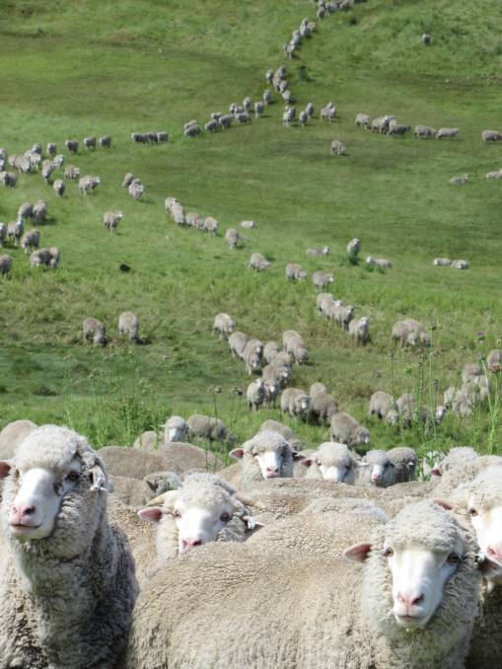
FLOCK: Kia Ora Merino.
The Winslow farm is over 1200 acres and shears 10,000 sheep for their award-winning Ethical, Sustainable, Profitable wool production.
They use Warrnambool veterinarian Dr David Beggs' Biocheck Biosecurity plan with all farm welfare, quality and management processes and procedures. Kia Ora Merino also uses the AWEX WoolClip app, which is used in conjunction with QR/RFID tracking on each wool bale which allows for tracking from farm to product.
Kia Ora Merino does not have footrot, lice or drench resistance.
Mrs Finnigan said they constantly received feedback about their wool products and encouraged other farmers to use awards as a way of spreading awareness about their brands.
"I had an email a day ago from lady who wants to source wool from us because we align with her values," Mrs Finnigan said.
"Our feedback is that the consumers want quality wool, not low yielding wool.
"We were humbled but also delighted to be nominated for this award and winning was fantastic.
"I'd encourage all farmers to apply for awards and accept nominations because it gives you a point of difference in the market."

